1. If we get any new product and the below error message "**New item requiring a multiplication factor**" then we required to updated the Factor table Allergan_NORWAY_Factors

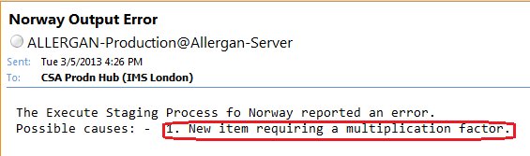

2. Write the below query to make sure we have new product inserted into factor table which require to update

select * from Allergan_LUXEMBOURG_Factors where manufacturer is null

If this query returns records having Country, Manufacturer and Factor is Null then New record has inserted into Allergan_NORWAY_Factors

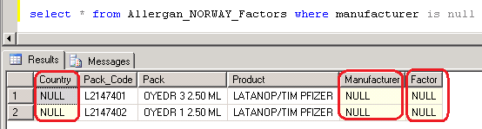

3. For Manufacturer details - Need to ask to LO. Run the below query and send the mail to LO

select * from Product_pack_code_allergan_LUXEMBOURG

where pack_code in

(

select pack_Code from Allergan_LUXEMBOURG_Factors

where manufacturer is null

)

**Mail Format**

Mail To : Lund, Thomas Nymoen (Stockholm); Holmquist, Peter (Stockholm)

Mail CC : CSA Prodn Hub (IMS London), Nasir, Tanveer

Mail Subject : Allergan Norway Mon'YY data - Manufacturer details required

Hi Thomas,

While processing Norway Mon’YY data, We have observed the below new pack.

|  |  |  |  |  |
| --- | --- | --- | --- | --- |
| **Product Code** | **Product** | **Pack Code** | **Pack Description** | **Manufacturer** |
| P2068001 | DIAMOX SA | L2068001 | TAB ENDOS 250 MG 1 | ? |

Could you please let us know the manufacturer for the above pack?

4. For Factors details - Need to ask to Allergan. Run the below query and send the mail to Allergan

select pack_Code from Allergan_NORWAY_Luxembourg

where manufacturer is null

**Mail Format**

Mail To : ML-Sales-Ops-Ophtha@Allergan.com

Mail CC : CSA Prodn Hub (IMS London), Nasir, Tanveer

Mail Subject : Allergan Norway Mon'YY - Factor Required for new pack

Dear All,

While processing Norway Oct’12 data, we have observed the below new pack.

|  |  |  |  |  |
| --- | --- | --- | --- | --- |
| **Product Code** | **Product** | **Pack Code** | **Pack Description** | **Factor** |
| P2068001 | DIAMOX SA | L2068001 | TAB ENDOS 250 MG 1 | ? |

Could you please let us know the factor for the above pack?

4. Once the above details are received, updated in the Table **Allergan_NORWAY_Factors**

update Allergan_Luxembourg_Factors

set

manufacturer = '',

factor = 1.000

where pack_code = ''

5. Run the below query to check if there is any blank information is available or not

select * from Product_pack_code_allergan_Norway

where pack_code in

(

select pack_code from Allergan_NORWAY_Factors

where manufacturer is null

)

6. Start the Production process.